The Basis 850 Framework
- What actually Limits Quality of Life?
While premature mortality is often perceived as the primary health risk, epidemiological and clinical evidence suggests that progressive illness and functional decline represent a far greater long-term burden for most individuals, (Lunney et al, 2003). In contemporary aging populations, extended survival is frequently accompanied by increasing multimorbidity, mobility limitations, cognitive impairment, and loss of independence.
These factors are the primary drivers of reduced quality of life, increased healthcare utilization, and diminished social and occupational engagement. Rather than longevity alone, it is sustained physical, metabolic, and cognitive function that determines whether additional years are lived with autonomy and purpose.
In this context, healthspan, the period of life spent in good functional health, represents a critical personal and societal asset. Preserving healthspan means maintaining vitality, resilience, and the capacity to participate fully in daily life for as long as possible.
- Healthspan vs Lifespan, What’s the difference?
Lifespan refers to the total duration of life, measured as the number of years between birth and death. Advances in medical care, public health, and living standards have significantly increased average lifespan across most populations. However, these gains have not always been accompanied by equivalent improvements in functional health.
Healthspan, by contrast, refers to the length of time an individual remains physically, cognitively, and metabolically capable of independent and productive living. It encompasses multiple interrelated domains, including cardiorespiratory fitness, muscular strength and power, mobility, metabolic regulation, cognitive performance, and psychological resilience.
A growing body of research demonstrates that it is possible to extend lifespan while experiencing prolonged periods of disability, frailty, and chronic disease. This divergence between lifespan and healthspan represents one of the central challenges of modern aging.
The Basis 850 framework is designed to address this gap by systematically assessing and supporting the functional systems that underpin long-term independence and wellbeing. Our objective is not merely to prolong life, but to maximize the proportion of life spent in robust, high-quality health.

- The silent decline
From approximately the mid-30s onward, gradual declines in multiple physiological systems begin to emerge, including cardiorespiratory capacity, skeletal muscle mass and power, metabolic flexibility, and certain domains of cognitive performance. These changes typically occur progressively and often remain subclinical for many years, exerting minimal immediate impact on daily functioning.
Because early-stage decline is slow and largely asymptomatic, it frequently goes unnoticed in routine life and is rarely detected through standard medical screening. Individuals may therefore perceive themselves as healthy while underlying functional capacity is steadily diminishing.
Clinical symptoms and functional limitations often manifest only after substantial physiological reserve has already been depleted. By the time measurable impairments in mobility, endurance, metabolic regulation, or cognition become apparent, meaningful reductions in baseline capacity have frequently already occurred.
Moreover, although targeted interventions can slow, halt, or partially reverse certain aspects of functional decline, recovery is often incomplete once critical thresholds have been crossed. In many cases, prolonged inactivity, metabolic dysfunction, or neuromuscular degradation leads to structural and cellular changes that limit the potential for full restoration.
This pattern underscores the importance of early, systematic assessment and proactive intervention before functional deterioration becomes clinically evident.

- Longitudinal Healthspan Model
The Basis 850 framework is designed as a longitudinal partnership model rather than a single-point assessment. As illustrated in Figure X, individuals first establish a functional baseline through standardized multi-domain testing. This data are then integrated into a composite Biological Functional Age and Healthspan Index through our proprietary AI, which it then forecasts over the next decade to examine what you may or may not be able to do in the next five & ten years through our Vital 50 & Elite 15 activities. Our proprietary AI then utilises all this data to create individualized intervention protocols.
Subsequent reassessments enable dynamic recalibration of risk profiles, functional trajectories, and intervention priorities. This iterative structure is intended to support sustained functional capacity, early identification of decline, and continuous optimization over time. All five pillars might look okay right now however this can change in as little as 6 months in which case our testing will catch it immediately.
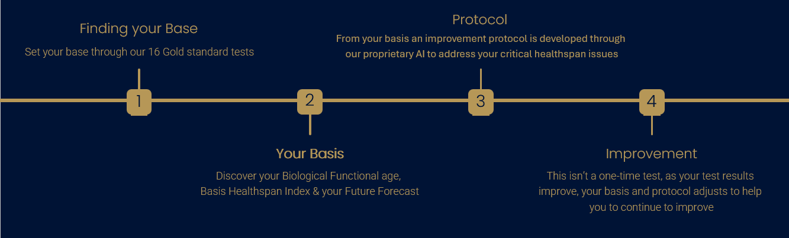
Fig.1 Longitudinal Healthspan Model

- The Five pillars
Our system starts with the 16 gold-standard tests conducted within each of the Five pillars which are Vitality, Strength & Power, Functional Mobility, Metabolic Health and Cognitive Performance. We’ll start by looking at the tests themselves and why based on our research they are the gold-standard tests & results when it comes to Healthspan.

  - Vitality
Regarding vitality, the two gold-standard tests we conduct are a VO2 Max test and a spirometry test to establish FEV1 which both have a lot of evidence backing them.
5.1.1 Spirometry & FEV1
Starting with the FEV1, spirometry is used by the HSE to assess how an individual inhales or exhales volumes of air as a function of time (O’Brien et al, 2022).
Multiple studies now treat lung function, especially the FEV1, as an independent cardiovascular and mortality risk factor. A general population of 15,010 adults in a Gutenberg Health Study reported that “the lung function metrics FEV1 & FVC are linked to all-cause mortality on the general population, independent of cardiac function.” (Magnussen et al, 2017).
A Lancet Global Health analysis of >170,000 individuals concluded: “reduced FEV1 is a strong, independent and highly generalised predictor of mortality & cardiovascular disease and respiratory outcomes…. Impaired lung function is a stronger risk factor for mortality & cardiovascular disease events than are most currently accepted conventional risk factors, accounting for one in four deaths and one in six cardiovascular disease events” (Duong et al, 2019).
A pooled analysis conducted in 2024 also emphasised this, “Reduced FEV1 & FVC represent robust risk factors for cardiovascular disease and mortality…. The increased risk was evident also at FEV1 & FVC levels exceeding 80% predicted, challenging the notion that the entire range above 80% is ‘normal’.” (Rydell et al, 2024)
5.1.2 VO2 Max
VO2 max also has significant amounts of publications backing it as an indicator of overall vitality. In 2024 an overview of meta-analyses, over 20.9 million observations from 199 cohort studies, concluded that, “Cardiorespiratory fitness is a strong and consistent predictor of morbidity and mortality among adults… Comparing high versus low CRF, there was a 41–53% reduction in risk of premature mortality.” (Lang et al, 2024).
A JAMA Network Open cohort of 122,007 adults undergoing treadmill testing found that, “Cardiorespiratory fitness was inversely associated with all-cause mortality without an observed upper limit of benefit… Extreme cardiorespiratory fitness (≥2 SDs above the mean for age and sex) was associated with the lowest risk-adjusted all-cause mortality compared with all other performance groups.” (Mandsager et al, 2018).
Another journal on the National Library of Medicine examined VO2 max as a key predictor of longevity and concluded that “Cardiorespiratory fitness, as measured by maximal oxygen uptake (VO₂max), is related to functional capacity and human performance and has been shown to be a strong and independent predictor of all-cause and disease-specific mortality.” (Strasser et al, 2018).
Based off this research, and the combination of both VO2 max with FEV1, gives a robust, scientifically grounded backing for the Vitality Pillar testing that reflects both everyday functional capacity and long-term health span.

  - Strength & Power
Within our strength & power pillar we conduct three tests; grip strength, sit-to-stand (STS) and Vertical Jump.
    - Grip Strength
There is very strong evidence that grip strength is a valid, global strength and health biomarker. A major review explicitly calls grip strength “an indispensable biomarker for older adults” and states that it is “largely consistent as an explanator of concurrent overall strength, upper limb function bone mineral density and lower limb strength, as well as being predictive of future disability, morbidity and mortality” (Bohannon, 2019).
Large cohort studies also show that lower grip strength predicts all-cause and cardiovascular mortality independent of other risk factors. One Tromoso Study analysis found that “a 1SD reduction in grip strength was associated with HR=1.17 for all-cause mortality….. These associations were similar in both genders and across age groups, which supports the hypothesis that grip strength might be a biomarker of ageing over the lifespan.” (Strand et al, 2016).
An umbrella review of handgrip strength and health outcomes similarly concludes that low grip strength is consistently associated with disability, frailty, hospitalisation and premature death (Soysal et al, 2021).
    - Sit-to-Stand (STS)
A 2021 validity study of the STS muscle power test reported that “there was no significant difference between force plate derived STS power and the estimated STS power obtained from the STS power test and both were strongly correlated… Both Force plate-derived and estimated relative STS power values exhibited similar relationships with measures of physical function in well-functioning older adults.” (Baltasar-Fernandez et al, 2021).
Another study assessing the STS power test found that, “the STS showed adequate validity and reliability in measuring lower body power in community-dwelling older adults. The test is quick, relatively inexpensive, safe and portable and thus should be considered for use in aging research” (Balachandran et al, 2021)
A broader view on lower limb function notes that the STS test are standard tools to assess lower limb strength & function and are part of sarcopenia and frailty screening (Park & Shin, 2024).
Based off these reports the STS based power is a valid, reliable test for lower limb strength & power that correlates closely with walking speed, mobility and independence in older adults.
    - Vertical Jump
Vertical jump measures are increasingly being recognised as safe and accurate indicators of lower limb power and functional capacity. In a 2022 paper it was reported that “results showed that vertical jumping tests are safe and accurate for assessing physical performance and are useful for monitoring age-related loss of muscle performance in robust older women.” (Santos et al, 2022) and that they found “significant positive correlations between vertical jump performance and gait speed, handgrip strength, and isokinetic knee strength, and negative correlations with TUG and 5xSTS times” (Santos et al, 2022).
A longitudinal study in community dwelling older adults focused on jumper power as a proxy for muscle power and “its potential to longitudinally predict the functional outcomes of functional geriatric assessment… vertical jump parameters… have the potential to predict functional tests of geriatric assessment within 2 years.” (Diekmann et al, 2022).
Therefore, the vertical jump is a validated, functional test of lower-lib power that is safe in screened older adults and predictive of future mobility and functional assessment scores.

  - Metabolic Health
The Metabolic Health pillar combines body fat percentage, waist-to-height ratio, HOMA-IR, ApoB, hs-CRP, fasting glucose and HbA1c to quantify cardiometabolic risk and insulin sensitivity. Elevated HOMA-IR trajectories are independently associated with higher incidence of cardiovascular disease and nearly doubled all-cause mortality (Lee et al, 2023). ApoB is now recognised as a more accurate marker and treatment target for atherogenic lipoprotein burden than LDL-C, particularly in patients with obesity, diabetes or metabolic syndrome (Behbodikhah et al, 2021).
Central adiposity and excess body fat (WHtR >0.5; body fat ≥27% in men and ≥44% in women) are linked to substantially higher all-cause and cardiovascular mortality (Savva et al, 2013; Mainous et al 2025). High-sensitivity CRP adds an independent inflammatory signal for cardiovascular events, while even ‘pre-diabetic’ fasting glucose and modestly elevated HbA1c are associated with increased risk of death, coronary disease and stroke (O’Sullivan et al, 2006).
Together, these tests provide a robust, multi-dimensional picture of metabolic health that goes far beyond traditional cholesterol checks and are therefore used to define the Metabolic Health pillar and Metabolic Age.

  - Functional Mobility
All the functional mobility tests are widely used, well validated markers of functional mobility, balance and flexibility. The four tests that make up the functional mobility pillar are: the gait speed walking test, timed up & go (TUG), single leg stance and sit & reach flexibility test.
    - Gait speed
Usual gait speed over 4 m is a simple, reliable performance test and is considered one of the best single summary measures of physical capacity in older adults. Slower gait speed consistently predicts disability, falls, hospitalisation and mortality, which is why it is recommended as a standard marker of multisystem health in community-dwelling adults (Kim et al, 2016; Bohannon & Wang, 2019).
    - Timed up and Go (TUG)
The TUG is a validated test of dynamic balance, lower-limb strength and mobility in community-dwelling adults. Normative values by age/sex exist, and longer times are associated with higher fall risk, functional decline and hospitalisation, leading major reviews to recommend TUG as a core evidence-based capacity test (Svinøy et al, 2021; Reis et al, 2025).
    - Single Leg Stance
The one-leg standing test is a standard, reliable measure of static balance that is widely used in clinical and research fall-risk screening tools. Short stance times (for example, under 5–10 seconds depending on cut-point) are associated with impaired balance and a higher risk of injurious or recurrent falls (Blodgett et al, 2022; Frisendahl et al, 2022).
    - Sit & Reach Flexibility Test
The sit-and-reach test has been used for decades as a simple field test of flexibility, primarily reflecting combined hamstring and lumbar spine mobility. It shows acceptable reliability when standardised and is widely used in health and fitness settings because reduced flexibility in this region relates to low-back problems, altered posture, gait limitations and higher fall risk (Topendsports, 2025; Green, 2025).

  - Cognitive Performance
For our cognitive testing we utilise the creyos cognitive battery of tests. The cognitive tests used here are adapted from well-established neuropsychological tasks, have been mapped to specific brain networks in functional imaging and lesion studies, and are supported by a very large normative database, allowing comparison of your performance to people of your age and sex (Creyos, 2022; Creyos 2022).
These tasks have shown good reliability and strong agreement with longer traditional cognitive assessments and have been used in hundreds of peer-reviewed studies across conditions such as dementia, stroke, depression and ADHD, so they provide a scientifically robust snapshot of your brain function across memory, reasoning, attention and verbal abilities (Kochan et al 2022; Honarmand et al 2019).

- Functional Biological Age

  - An Overview
Once a client has completed our 16 gold-standard tests, our proprietary AI takes these results and compares them to normative data, for each test, relative to the person’s age. An individual pillar score is then calculated which is then used to calculate a client’s functional biological age.

  - The Normative Data Sets
6.2.1 Vitality
Our VO2 Max & FEV1 normative data is taken from the Cooper Institute for Aerobics Research Dallas Texas. It is widely regarded as the gold-standard for VO2 Max & FEV1 classification & data because of its unmatched scale, longitudinal depth, and clinical integration. The data itself is derived from over 100,000 individuals collected over several decades. Unlike many field tests that rely on self-reporting or varied protocols, the Cooper data was largely built on treadmill stress testing conducted in a controlled, clinical environment. The institute itself has been the primary authority on preventative medicine and aerobic fitness since 1970 (Cooper Aerobics, N/A).

6.2.2 Strength & Power
6.2.2.1 Grip Strength
Firstly, we’ll look at the normative data we use for grip strength. Our normative data for grip strength comes from a study conducted in 2014, “Grip strength across the life course: normative data from twelve British studies”, (Doods et al, 2014). Before this study, most normative data focused solely on the elderly or solely on young athletes. This study and data set allows us to see the entire trajectory of human strength from development to peak to decline. It covers 49,964 participants and 60,803 observations. Grip strength is notoriously finicky in that results change if you stand up, sit down or use a different dynamometer, however the Dodds study performed sensitivity analyses and found that these normative values remained accurate regardless of whether the subject was seated or standing and didn’t vary no matter what brand of dynamometer was used. This is why the Dodds data set is regarded as the gold-standard when it comes to grip strength.
6.2.2.2 Vertical Jump
Next, we examine the normative data set we use for vertical jump, which is derived from the Canadian Health Measures Survey (CHMS). Specifically, we utilize the nationally representative percentile values established in the study 'Normative-referenced percentile values for physical fitness among Canadians' (Hoffmann et al., 2019), published in Health Reports.
While most vertical jump charts found online originate from NBA, NFL scouting, or NCAA college studies, these sources are heavily skewed toward elite athletes. The CHMS dataset, however, is far more accurate for our purposes as it represents a true cross-section of the general population aged 6 to 79, collected by Statistics Canada using a highly rigorous, standardized protocol.
6.2.2.3 Sit-to-Stand (STS)
For STS we utilise a data set from a 2020 study "Reference values for the 5-repetition sit-to-stand test" (Alcazar et al, 2020). Before this study, the STS test was viewed almost exclusively as a geriatric test with most normative data only starting at 60 to 65 which obviously wouldn’t be useful to us. Due to the dataset including young, middle-age and elderly adults it has become a gold-standard for clinicians to spot early warning signs of sarcopenia. The study also enforced a rigorous protocol which is now the industry standard when conducting this test. These factors are why we utilise this data set.

6.2.3 Functional Mobility
6.2.3.1 Gait speed
For our gait speed normative data, we refer to the study conducted by Bohannon & Wang, 'Four-meter gait speed: normative values and reliability determined for adults participating in the NIH Toolbox Study' (2019). While most gait speed studies focus exclusively on the elderly to screen for fall risk, this study utilizes the extensive NIH Toolbox dataset to map walking speed across the entire adult lifespan (ages 18–85+). It establishes updated benchmarks specifically for the 4-meter walk test, the modern clinical standard for space-constrained assessments documenting the natural peak and decline of gait velocity with high precision. This ensures our rehabilitation goals are not only age-appropriate but also aligned with the most current, nationally representative standards, which is why we utilize the Bohannon & Wang (2019) dataset as our normative data.
6.2.3.2 Timed up & Go (TUG)
Before 2006 TUG norms were scattered across dozens of small studies often with conflicting results. This is why we use Reference values for the Timed Up and Go Test: A Descriptive Meta-Analysis" by Richard W. Bohannon, published in the Journal of Geriatric Physical Therapy, (Bohannon, 2006). Bohannon didn’t just run one test, he aggregated data from 21 different studies, smoothing out the statistical noise and outliers found in smaller project. The resulting number represent a mathematical consensus of what “normal” mobility data looks like. While the majority of data in the study examines people above the age of 60, it does examine people below this age and explains that there is a “floor effect” where if you are healthy there’s almost no variance between scores, “whether you are 20, 30 or 40 you will likely complete the test in 6-8 seconds. There is almost no variance” (Bohannon, 2006). Thus, us why we use the data set from Bohannon.
6.2.3.3 Single Leg Stance (SLS)
Like the other normative data sets, most SLS studies are designed strictly for fall risk assessment in the elderly, however this 2007 study "Normative values for the unipedal stance test with eyes open and closed" by Barbara A. Springer et al published in the Journal of Geriatric Physical Therapy covers the entire adult lifespan (18-99 years). It also has a robust protocol making the data much more accurate than other tests where participants could “cheat” by waving their arms, allowing them to balance for much longer.
6.2.3.4 Sit & Reach Flexibility Test
For the sit & reach flexibility test we use the ACSM’s guidelines for exercise testing and prescription (11th edition, 2021) because unlike individual papers, the ACSM guidelines represents a consensus statement from the largest and most influential governing body in sports medicine. One of the biggest issues with the Sit & Reach test is the equipment. Some boxes start at 15 cm, some at 23 cm and some at 26 cm. The ACSM guidelines strictly standarise the protocol using the sit and reach box with the zero point at 26 cm or the modified “zero point” method. Without this standardisation protocol, a score of 30 cm is meaningless. The ACSM also provides highly granular tables that separate men and women and break down norms by decade of life which ensure that you’re conducting a fair assessment. For example, it won’t compare a 50 year old man to a 20-year-old female dancer. This is why their data set is considered the gold standard.

6.2.3.4 Metabolic Health
For our Metabolic Pillar, we utilize a stratified risk model based on established clinical consensus statements rather than simple population averages. Our normative ranges are derived from the following gold-standard preventative guidelines:
- Inflammation (hsCRP): We adopt the CDC/AHA (2003) risk stratification, which defines <1.0 mg/L as low cardiovascular risk, 1.0–3.0 mg/L as average risk, and >3.0 mg/L as high risk.
- Insulin Resistance (HOMA-IR & HbA1c): We align with the American Diabetes Association (ADA) standards, designating HbA1c >5.7% as 'Elevated' (Pre-diabetic). Furthermore, we utilize HOMA-IR thresholds validated by Gayoso-Diz et al. (2013), identifying scores >2.5 as indicative of insulin resistance and scores <1.5 as optimal sensitivity.
- Lipid Health (ApoB): We utilize National Lipid Association (NLA) risk stratifications, defining <90 mg/dL as the low-risk therapeutic target and >130 mg/dL as elevated risk.
- Central Adiposity (WHtR): We follow the Ashwell & Gibson (2016) and NICE classifications, utilizing 0.5 as the boundary for healthy visceral fat levels and 0.6 as the critical threshold for significant metabolic risk.
- Body Composition (Body Fat %): We adopt the Gallagher et al. (2000) normative guidelines, which calibrate body fat percentage to the WHO and NIH BMI-based health thresholds. Unlike static charts, this model stratifies risk by age (20–79) and gender, defining "Healthy," "Overweight," and "Obese" ranges that dynamically adjust to account for the natural physiological increase in adipose tissue associated with aging.

6.2.3.5 Cognitive performance
For cognitive performance we utilise the Creyos Cognitive test which has its own gold standard normative data base. This database is considered the gold standard because for several reasons. Firstly, unlike most traditional neuropsychological tests which rely on normative groups of 2000 to 3000 people, Creyos’s database has grown from a global scientific initiative to include over 12 million cognitive test scores and 30 years of research validated in peer- reviewed journals like “Neuron” (Hampshire et al, 2012). This ensures the data set is robust and devoid of human errors.

  - The Weighting
Our proprietary AI applies a weighted, multi-domain framework to integrate physiological, metabolic, and cognitive markers into a unified Functional Biological Age and Healthspan Index which you can see below in figure 2. Pillar and sub-test weightings were initially derived through structured synthesis of high-quality epidemiological evidence, clinical consensus statements, and established risk stratification models.
This approach reflects current best practice in early-stage clinical risk modelling, where theory-driven weighting is used as an initial framework prior to large-scale empirical calibration.

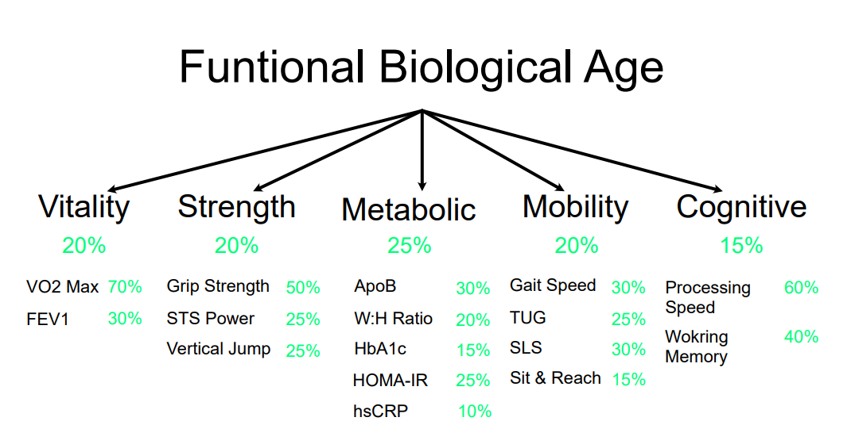
Fig.2 Test & Pillar weighting for calculations
    - Weighting Justification
6.3.1.1 Metabolic Health (25%)
Metabolic Health is weighted most heavily (25%) due to its central role as an upstream driver of multisystem pathology. Insulin resistance, dyslipidemia, visceral adiposity, and chronic inflammation are well-established antecedents to cardiovascular disease, sarcopenia, neurodegeneration, and functional decline.
Multiple longitudinal cohorts demonstrate that ApoB, HOMA-IR, HbA1c, and hsCRP independently predict all-cause mortality and cardiovascular events. Given their mechanistic involvement in disease progression and responsiveness to intervention, this pillar is prioritized within the model.
Sub-weight rationale reflects relative prognostic strength and clinical relevance:
- ApoB (30%): Primary marker of atherogenic burden
- HOMA-IR and HbA1c (40% combined): Indicators of insulin resistance and glycemic control
- Waist-to-height ratio & Body fat %(20%): Proxy for visceral adiposity
- hsCRP (10%): Marker of systemic inflammation

6.3.1.2. Vitality (20%)
Vitality is weighted at 20% in recognition of cardiorespiratory fitness as one of the strongest predictors of longevity and functional independence.
VO₂max and FEV1 demonstrate consistent inverse associations with mortality across large population studies. However, the weighting is moderated to balance survival-related metrics with measures of physical capability and autonomy.
Sub-weighting reflects relative predictive strength:
- VO₂max (70%)
- FEV1 (30%)

6.3.1.3 Strength & Power (20%)
Strength and Power are critical determinants of physical independence, fall risk, and frailty. Sarcopenia and dynapenia are strongly associated with disability, institutionalization, and mortality.
This pillar is weighted at 20% to reflect its central role in maintaining functional capacity across the lifespan.
Sub-weighting emphasizes global and task-specific performance:
- Grip strength (50%)
- Sit-to-stand power (25%)
- Vertical jump power (25%)

6.3.1.4. Functional Mobility (20%)
Functional Mobility reflects the integration of neuromuscular control, balance, coordination, and joint function. Impairments in this domain are strong predictors of falls, hospitalization, and loss of independence.
Equal weighting with Strength and Vitality reflects the clinical reality that force production without adequate control confers limited functional benefit.
Sub-weighting prioritizes fall prevention and locomotor capacity:
- Single-leg stance (40%)
- Gait speed (30%)
- Timed Up and Go (20%)
- Sit-and-reach flexibility (10%)

6.3.1.5. Cognitive Performance (15%) – The Executive Controller
Cognitive Performance is weighted at 15% in recognition of its importance for quality of life, executive functioning, and long-term independence.
In early and mid-adulthood, short-form cognitive testing demonstrates greater inter-individual variability and lower short-term predictive stability than physical biomarkers. Additionally, many physical and metabolic interventions exert indirect effects on cognition over longer time horizons.
Accordingly, cognition is weighted as a downstream and partially lagging indicator within the current healthspan framework.
- Sub-weighting reflects domain sensitivity:
- Processing speed (60%)
- Working memory (40%)

6.3.2 Weighting Robustness & Testing
The current weighting structure represents a theoretically grounded and evidence-informed initial framework.
In subsequent development phases, weights will be empirically refined through outcome-based modelling using longitudinal datasets.
To ensure stability and clinical reliability, future analyses will evaluate model sensitivity to variations in pillar and sub-test weights. This will assess whether individual-level risk stratification and forecasting remain consistent across plausible parameter ranges.

  - Example Biological Functional Age
In figure 3 below are our example Persona Paul’s test results. Paul is a, forty-eight year old, high-ranking corporate executive. To the outside world, Paul looks quite healthy; he commands the boardroom with an imposing physique and maintains a gym schedule four times a week. However, that visible strength masks a stiffer reality. A keen observer might notice his gait is rigid rather than fluid, a result of limited range of motion in his knees and shoulders. While he functions at a high level, he deals with persistent, low-grade joint pain that occasionally disrupts his sleep. Using Paul’s results we can calculate his Biological Functional Age.

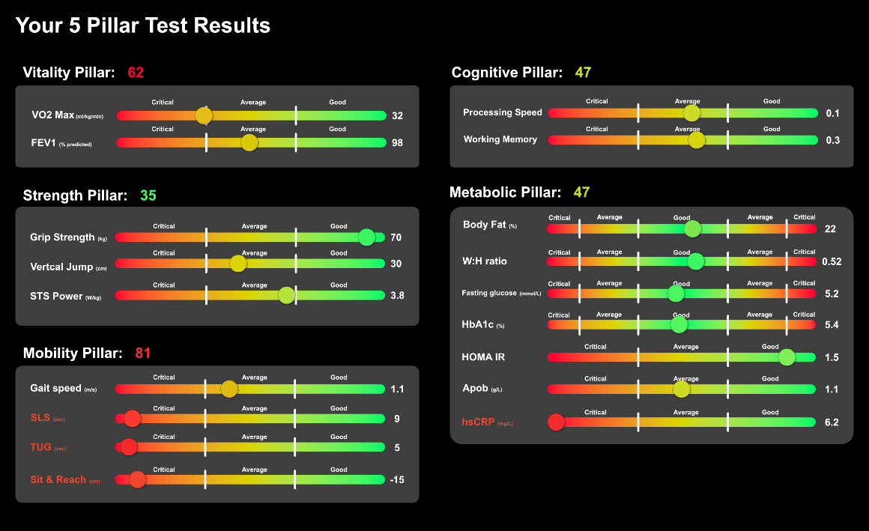

Fig.3 Paul’s Test Results

From his test results our proprietary AI can then calculate his individual Pillar scores, shown below in Figure 4., using the normative data and weighting discussed above in 2.3 & 2.2.
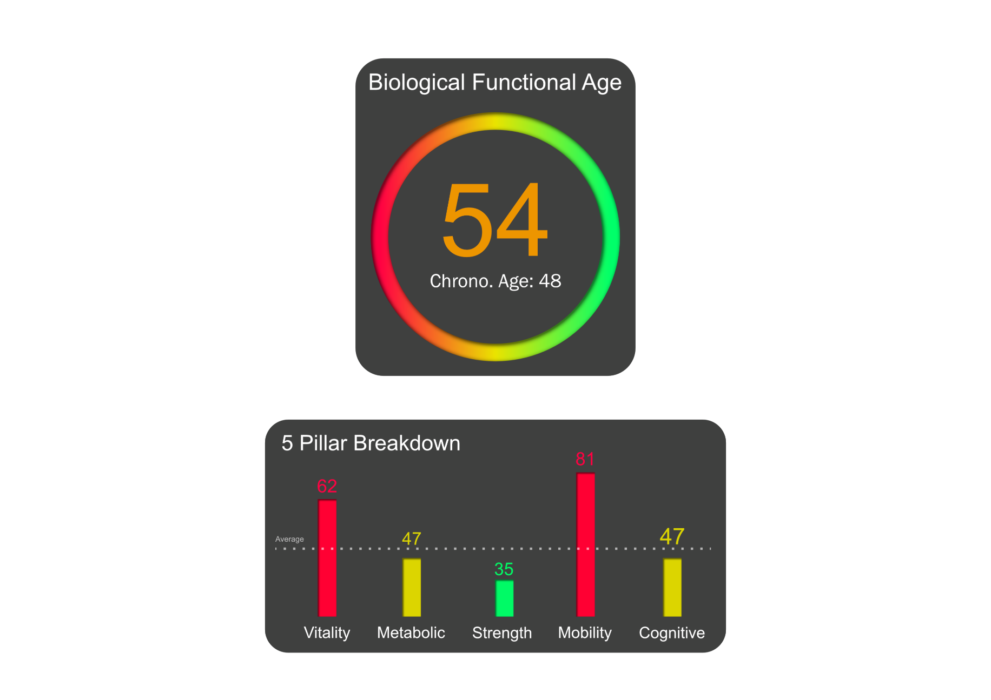
Fig.4 Paul’s 5 Pillar Results

From these 5 pillars scores our proprietary AI can then calculate Paul’s Biological Functional Age, shown below in figure 5, which shows how he is actually functioning using the weighting discussed above in 2.3. As we can see Paul is functioning like 6 years older than he actually is.
Fig.5 Paul’s Biological Functional Age

- The Healthspan Index
The Healthspan Index is the single number that brings your entire assessment together. It is designed to answer one essential question; how well are you actually aging compared to people like you?
Much like a credit score reflects your financial health, the Healthspan Index reflects the current and future state of your physical, metabolic, and functional capacity. Using your test results, Biological Functional Age, and peer comparisons, our proprietary AI generates a score between 300 and 850 that represents how resilient, capable, and future-ready your body truly is.
This is not a vanity metric. It is a practical, evidence-informed indicator of how well your body is positioned for the decades ahead.
In Paul’s case, his Healthspan Index is 537, placing him in the Poor category (Figure 6). While he appears strong and successful on the surface, this score reveals meaningful vulnerabilities that, if left unaddressed, are likely to limit his independence and quality of life over time.

7.1 Healthspan Index Categories
Each score range reflects a distinct level of functional health and long-term resilience:
- Critical (300–459): High risk of early functional decline and chronic disease
- Poor (460–549): Below-average resilience with clear areas of vulnerability
- Fair (550–599): Functional but fragile; improvement is needed
- Average (600–649): Typical for age, but far from optimal
- Good (650–699): Strong foundation for long-term health
- Excellent (710–799): High functional capacity and low risk profile
- Elite (800–850): Exceptional resilience and performance for age
These categories provide immediate context. They show clients exactly where they stand today, and how far they can go. You can see an example of Paul’s healthspan index below in figure 6.
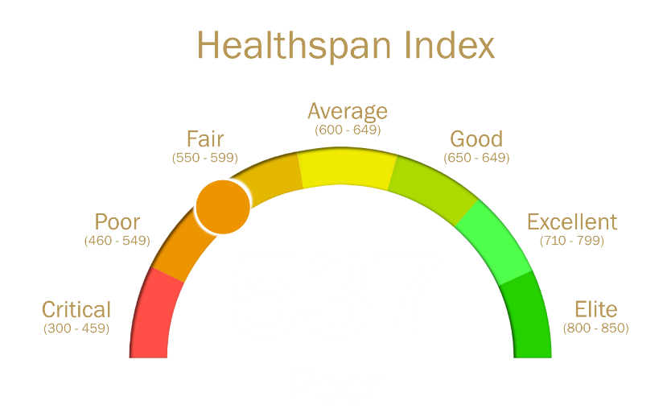

Fig.6 Paul’s Healthspan Index

7.2 Why the Healthspan Index Matters
Most health metrics exist in isolation: a cholesterol number here, a blood pressure reading there, a fitness test somewhere else. On their own, they are difficult to interpret and easy to ignore.
The Healthspan Index changes that.
It transforms dozens of complex measurements into a clear, motivating signal. It shows, at a glance, whether your current lifestyle is building resilience, or quietly eroding it.
More importantly, it turns progress into something visible.
As clients follow their Improvement Protocol and retest over time, the Index updates. Gains in fitness, metabolic health, mobility, and recovery translate directly into a rising score. Effort becomes measurable. Improvement becomes tangible. Motivation becomes sustainable.

7.3 From Awareness to Momentum
For many clients, the Healthspan Index is the moment everything “clicks.”
It replaces vague reassurance with clarity.
It replaces uncertainty with direction.
It replaces passive concern with active control.
Rather than wondering whether they are “doing enough,” individuals can see, in real time, how their choices shape their future capacity.
Over time, the Index becomes more than a number. It becomes a personal benchmark, a source of accountability, and a powerful incentive to move beyond average and toward long-term excellence.
In this way, the Healthspan Index does not simply measure aging.
It helps people take ownership of it.

- AI Powered Forecasting
Our Proprietary AI utilises peer comparative decline and improvement rates to forecast what clients potentially will or won’t be able do in five and 10 years. Similar to how our AI calculates someone’s individual pillar scores & biological functional age, it utilises the same weighting system for both the decline and improvement rates.

8.1 Decline rates
8.1.1 Vitality
For VO2 max, multiple reviews and cohort studies show that maximal oxygen uptake (VO2 Max) falls by roughly 10% per decade after early adult hood, with evidence of accelerated losses later in life, (around 70 years old) and in sedentary individuals, (Hawkins & Wiswell, 2003). This is also backed up by Letnes et al, 2023 & Fleg et al, 2005.
For FEV1, spirometry data indicates that FEV1 declines by roughly 1-2% per year from the mid-twenties onward, equivalent to around 10 – 20% per decade and that even these ‘normal’ age-related reductions are independently predictive of cardiovascular and all-cause mortality” (American Lung Association, 2025). This is also back by Ranu et al, 2011, Duong et al, 2019 & Rydell et al, 2024.
4.1.2 Strength & Power
Before talking about the decline rates of each of the tests, we must first take into consideration the muscle mass decline rate as this will influence the decline of everything else in the strength & power pillar.
Studies show that skeletal muscle mass decreases by approximately 3 – 8% per decade after the age of 30, with the rate increasing after 60 and that muscle mass & strength can decline by 1-2% per year after age 50 in inactive individuals. This underpins an expected 10-20% decline in strength per decade in our target range of 40 – 65 without any intervention. This is supported by Nishiguchi et al, 2014, Dunkin & Painter, 2024, Bangkok Hospital Headquarters, 2025 and Volpi et al, 2004.
Next, we can look at grip strength. Grip strength “peaks in midlife and then declines by about 1% per year, with cohort data in women showing a reduction of 0.19 kg/year between 50 and 67 and 0.45 kg/year after 67, and life-course analyses confirming an accelerated drop from later midlife onward. We therefore model a ~10% grip-strength decline per decade from 50 to 70, with faster losses beyond 70.” (Sternäng et al, 2015). These numbers are also supported by Dodds et al, 2014 and by Kaczorowska et al, 2025.
Both the sit-to-stand (STS) tests and vertical jump (countermovement jump) assess lower-extremity muscle power, which is a key determinant of mobility and fall risk. In community-dwelling older adults, performance on the 5-time sit-to-stand and countermovement jump tests is significantly associated with lower-limb strength and mobility measures, indicating they reflect the same underlying construct of leg power and functional capacity (Coelho-Júnior et al, 2024).
Reading articles, we can determine that for lower limb power roughly there’s a “10–15% lower power each decade from midlife into older age. When relative STS power falls to about 1 SD below age- and sex-specific norms, it is associated with dynapenia, sarcopenia, poor gait speed, cognitive impairment, hospitalisations, and higher risk of adverse outcomes.” (Campitelli et al 2021). This is also backed by the journal arcticle “Relative sit-to-stand power cut-off points and their association with negative outcomes in older adults” by Baltasar-Fernandez et al, 2021.

8.1.3 Metabolic Health
Ageing on its own shifts metabolic health in the wrong direction, even before anyone is “officially” sick. Longitudinal data in people without diabetes suggest fasting glucose drifts up by roughly 0.7–1.1 mg/dL per decade (Chia et al, 2019), with other cohorts putting it closer to about 1–2 mg/dL per decade (Refaie et al, 2006). Over the same period, HbA1c rises by around 0.010–0.014 percentage points per year (roughly 0.10–0.14% per decade), and the upper end of “normal” moves from about 6.0% below 40 to roughly 6.6% by 70+ (Pani et al, 2006).
On top of that, beta-cell insulin secretion (HOMA-IR) drops by about 0.7% per year, with roughly double that rate once someone already has impaired glucose tolerance (Szoke et al, 2008). Large cohort data also show metabolic syndrome becoming much more common with age, jumping from roughly 25% in younger adults to over 70% in older groups, which works out to about a 1% per-year increase in odds if nothing changes (Huang et al, 2022).
This is the rationale for the ‘no-intervention’ trajectory in the Metabolic Health pillar: a slow but persistent rise in glucose and HbA1c, a gradual loss of beta-cell reserve, and a steadily increasing chance of tipping into the metabolic-syndrome zone between 40 and 65 if behaviour stays the same.

    - Functional Mobility

      - Gait Speed
From mid-life onward, usual walking speed declines by roughly 5–8% per decade, and once usual gait speed drops below about 1.0 m/s there is a clear increase in risk of disability, hospitalisation and earlier death; below 0.8 m/s many everyday community tasks such as safe street crossing, shopping and walking several hundred metres become difficult or unsafe (Lee et al, 2019; Dommershuijsen et el, 2022).

8.1.4.2 Timed up and Go
In large community cohorts, median Timed Up and Go scores remain relatively stable from 60–65 years, but from about 65 onward they lengthen by roughly 0.14 seconds per year. Because usual straight-line gait speed only declines by around 0.7% per year in otherwise healthy older adults, much of that subtle slowing can be absorbed within the extra ‘slack’ of this compound task (standing up, turning, sitting), so population median TUG results do not shift dramatically until mobility impairment becomes more pronounced (Svinøy et al, 2023; Studenski et al, 2011).
8.1.4.3 Single leg Stance
Single-leg stance time falls by around 20% per decade of adult life, and times of 5 seconds or less are used in research as a marker of mobility limitation, where recovering from a trip, walking on uneven ground or climbing stairs without using a handrail becomes significantly more difficult (Stathokostas et al, 2013; Gao et al, 2022).

      - Sit & Reach Flexibility Test
Lower-limb and trunk flexibility, as captured by chair or floor sit-and-reach, tends to decline steadily from mid-life, with average losses on the order of several degrees or a few centimetres per decade, which progressively limits comfortable bending, tying shoelaces, picking objects from the floor and maintaining longer walking strides (Stathokostas et al, 2013; Gao et al, 2022).

8.1.5 Cognitive Performance
For healthy adults, fluid cognitive abilities such as processing speed, attention, working memory and reasoning tend to decline by roughly 0.2 standard deviations per decade from mid-life, with faster losses after 65, whereas vocabulary and general knowledge are largely maintained (Harada et al, 2013; Singh-Manoux et al 2012).
In practical terms, this means that over 10–20 years, even normal aging is expected to produce small but noticeable slowing when switching tasks, holding information in mind, or solving new problems, while language and well-learned skills are much more stable (Harada et el, 2013; Randhawa et al, 2020).

8.2 Improvement Rates
8.2.1 Vitality
For untrained individuals studies show that you can improve your VO2 max within 8 – 20 weeks by around 15% by consistently doing aerobic training (Huang et al,2005; Støren et al, 2017) Older individuals this seems to drop to somewhere between 10 – 15%. Trained individuals’ improvements are often smaller, in the range of 3-5% (Wilmore et al, 2004; Milanovic et al 2015).
For FEV1, this generally seems to be affected by people smoking or by lung diseases. If someone stops smoking, no further damage will be caused and if done early enough can return to a decline rate similar to people who’ve never smoked (Anthonisen et al, 1994). Similar to VO2 Max, regular aerobic exercise can help improve respiratory muscle strength and efficiency and, in some studies, saw a 2-5% improvement in FEV1(Holland et al, 2014).
8.2.2 Strength & Power
Studies show that over 8 -12 weeks, training 2 to 3 times a week that adults showed improvement in grip strength of 10 – 30% (Cruz-Jentoft et al, 2019; Peterson et al, 2010).
Studies on older adults show that 8–12 weeks of targeted training can lead to a 10–25% reduction in sit-to-stand time, which correlates directly to an increase in power output (Cheng et al., 2017; Binder et al., 2002).
Regarding the Vertical Jump (cm), improvement is tied to plyometric training and explosive strength exercises. For untrained or recreationally active individuals, improvements of 5–15% in jump height are achievable within 6–12 weeks of consistent training (Markovic & Mikulic, 2010; Stojanovic et al., 2017).

8.2.3 Functional Mobility
For Gait Speed (m/s), a multi-component exercise program (aerobic, strength, and balance) is the gold standard. Older adults with slower initial speeds can see improvements of 10–20% over 12–24 weeks (Daniels et al., 2012).
For Timed Up and Go (TUG), which measures agility and functional strength, targeted training can reduce the time taken (an improvement in score) by 10–25% within 8–12 weeks (Schoene et al., 2013).
In Single Leg Stance (sec), which measures balance, progress can be quite rapid. Studies show that 8–12 weeks of balance and proprioceptive training can improve stance time by 20–50% (Sherrington et al., 2017).
For Sit and Reach (cm), flexibility training through stretching, yoga, or Pilates is key. Consistent stretching 3–5 times per week can yield improvements of 5–15 cm in reach within 6–12 weeks (Apostolopoulos et al., 2015).

8.2.4 Metabolic Pillar
For Body Fat (%) and Waist to Height Ratio, the most effective intervention is a combination of a calorie-controlled, high-protein diet and both aerobic and resistance exercise. Sustainable improvements in body fat percentage are typically 0.5 –1% (absolute reduction) per month. Over a 3–6-month period, total reductions of 3 –6% are realistic for most people (Schoeller, 2009; Strasser et al., 2013). Similarly, a weight loss of 5–10% of total body mass can lead to a 5–10% reduction in the Waist to Height Ratio (Jensen et al., 2014).
For Fasting Glucose (mmol/L), HbA1c (%), and HOMA IR, interventions include dietary changes (low glycemic index, high fiber) and regular physical activity. In pre-diabetic individuals, lifestyle changes can reduce HbA1c by 0.3–0.6% over 6–12 months. For those with Type 2 diabetes, intensive interventions can see improvements of 0.5–1.5% or more, with significant normalization of insulin sensitivity (DPP Research Group, 2002; Colberg et al., 2016).
For ApoB (g/L), dietary shifts (low saturated fat, high soluble fiber) can reduce levels by 5–15% (Kritchevsky, 2000). If pharmacological intervention like statins is required, reductions can reach 30–50% or higher depending on the dose (Grundy et al., 2019).
Regarding hsCRP (mg/L), weight loss is the most potent intervention. A 5–10% reduction in body weight can lead to a 20–40% drop in inflammatory markers. Regular moderate exercise alone has also been shown to reduce hsCRP by 10–25% (Dandona et al., 2007; Kasapis & Thompson, 2005).

8.2.5 Cognitive Performance
For Processing Speed (SD) and Working Memory (SD), the most effective interventions are a combination of computerized cognitive training and aerobic exercise. Computerized "brain training" tasks specifically designed for speed and memory can improve scores by 10–20%, effectively reversing the equivalent of 5–10 years of natural age-related decline (Ball et al., 2002; Smith et al., 2009). Additionally, consistent aerobic exercise has been shown to improve cognitive scores by 0.2 to 0.6 standard deviations over 6 months by increasing hippocampal volume and neural efficiency (Erickson et al., 2011; Blondell et al., 2014).

Utilising the Decline & Improvement Rates
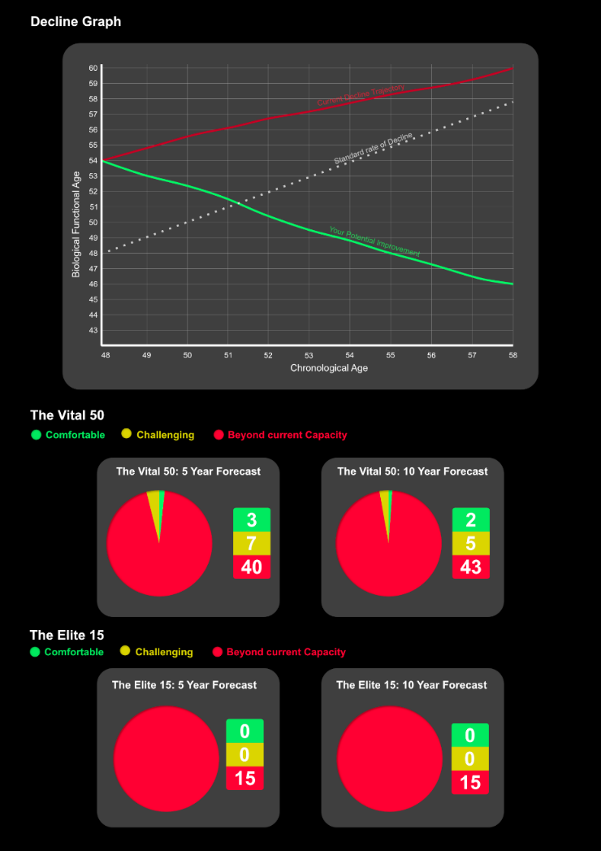
Using the decline & improvement rates our proprietary AI is then able to forecast what your biological functional age will be over the next decade if you don’t take any action versus where you will be if you do take action. At the same time, it will determine of our Vital 50 activities and Elite 15 what activities will you be able to do in 5 & 10 years’ time. We’ll come back to these in 4.4. We can look at Paul’s forecast graph and activities summary to see an example of how our proprietary AI uses the rates to forecast in figure 7.

8.4 Activities Forecasting
As we already mentioned, our proprietary AI uses the decline rates to determine what a person’s test results will potentially be be in 5 & 10 years. It then takes these and based off individual thresholds for each of our Elite 15 & Vital 50 activities, which can be seen in table 1 & table 2 below, determines whether a person will or will not be able to do an activity. The Vital 50 are activities that you will need to be able to do on a day-to-day basis, everything from opening a jar to lifting your grandchild to climbing the stairs. The Elite 15 are high performance activities like running a half marathon, competing in a hyrox or doing a deadlift with 1.5x your bodyweight.
Fig.7 Paul’s 5- & 10-Year Forecast

8.4.1 The Vital 50
The Vital 50 represent the core physical and cognitive capabilities required for independent, high-quality living in modern environments. They span daily self-care, occupational function, social engagement, emergency response, and recreational participation

The Vital 50
Standing up from chair/toilet | Route navigation in new area
Opening Jars/using utensils | 5km run
Carrying Grocceries | 10-minute jog on treadmill
Tying shoes/putting on socks | Cycle 10km on flat ground
Get in & Out of Bed | Play with children
Stair climbing (with rail) | Carry child for 10 minutes
Following multi-step instructions | Floor to waist lift (20kg)
Appointment Recall | Overhead lift 10kg
Swim 25m unaided | Floor to overhead lift 15kg
Getting in & out of car (low seat) | One arm carry (10kg)
Walking around the house | Catching falling object
Lifting grandchild (15kg) | Push heavy door
Stair climbing (without rail) | Long flight tolerance
Getting up off the floor | Sustained focus for 90 minutes
Gardening (60 minutes) | Multitasking speed
Putting Luggage overhead | New skill retention
Hiking on uneven ground | Rapid decision speed
Walk 2-3 km | Rising from low seating (Without hands)
Prolonged standing 60 – 90 mins | Emergency Brisk Walk (crossing street)
Laundry load carry | Reaching & retrieving from floor
Suitcase carry | Household cleaning endurance
Car boot loading | Carrying shopping up stairs
Pushing loaded shopping trolley | Kneeling & Rising (without support)
Direction change balance | Public transport stability
Day long energy | Descending stairs while carrying a light load (Laundry basket or shopping bag)
Table 1. The Vital 50

8.4.2 The Elite 15
The Elite 15 represent the upper threshold of human functional capacity across endurance, strength, speed, and competitive performance. They reflect the physical capabilities required not merely for independence, but for sustained high performance in demanding athletic, occupational, and recreational environments. Spanning cardiovascular endurance, neuromuscular power, muscular strength, and movement efficiency, these benchmarks serve as indicators of exceptional physiological resilience. Achievement within this domain reflects a body that is not only resistant to age-related decline, but capable of maintaining elite-level output and adaptability well into later life.

The Elite 15
Half Marathon (Sub 2 hours) | Pull ups 10+ Consecutive
Full Marathon | Push ups 50+ Consecutive
Competitive Marathon (sub 4 hours) | 100m Sprint under 15 seconds
Century Bike Ride | 10km run under 55 minutes
Olympic Triathlon | Competitive Sport Participation (League/Tournament)
Continuous Swimming 1km | Hyrox or Functional Fitness Competition
Deadlift 1.5x Bodyweight | Multi-day Hiking/Trekking
Back squat 1.25x Bodyweight
Table 2. The Elite 15
8.4.3 Paul’s Breakdown
10 Year
5 Year
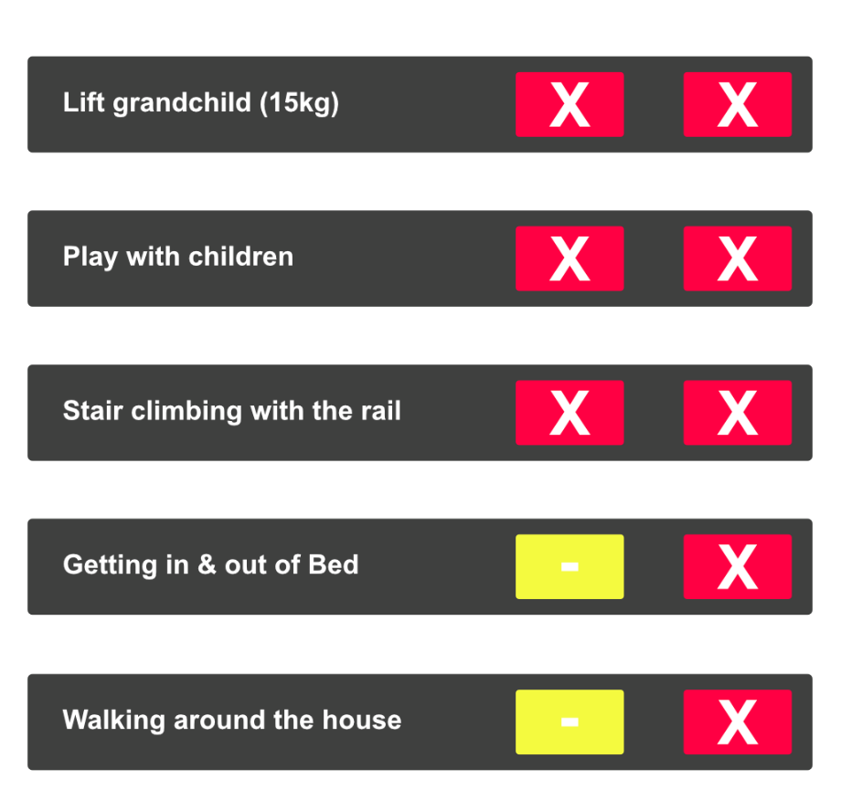
If we bring it back to Paul and look at his forecast, shown in figure 8 below, we can see that of the Vital 50 & Elite 15, in 5- & 10-years Paul will be able to complete almost none of them.

If we break this down and examine why he can’t do activities a pattern begins to emerge. For example, in both the five- and ten-year forecasting Paul will not be able to play with his grandchildren. This is initially because his timed up & go and single leg stance are below the minimum threshold to able to do the activity. This later becomes worse as his strength naturally begins to fade with age and his vertical jump test results join the indicators that he won’t be able to do this activity.
Fig.8 Example of Paul’s Forecast
These three results together indicate a problem getting up and down off the floor or from seated positions, balancing issues and a lack of power for running, jumping or changing speed. A person with very low mobility, balance, and leg strength doesn’t have the physical capacity to safely respond to a child’s fast, unpredictable movements. This makes playing difficult, unsafe, and exhausting, increasing the risk of falls or injury for both the adult and the child.

8.5 Early Warning System
One of the most powerful advantages of the Basis 850 framework is its ability to identify emerging health risks long before they become clinically obvious. By integrating multi-domain functional testing with longitudinal forecasting, the system detects early patterns of decline and physiological imbalance that often precede formal diagnosis by many years.
Rather than waiting for symptoms to appear, the Early Warning System highlights subtle shifts in metabolic control, cardiovascular risk, mobility, and resilience that signal increasing vulnerability. These changes frequently develop silently, progressing in the background while individuals continue to feel “generally healthy.”
In Paul’s case, his assessment reveals early indicators of metabolic dysfunction and elevated cardiovascular risk. While these findings may not yet require medical intervention, the projected trajectory suggests that, without corrective action, they are likely to worsen over time. Left unaddressed, this pattern substantially increases the probability of future conditions such as type 2 diabetes, fatty liver disease, accelerated muscle loss, coronary artery disease, and cerebrovascular events. Crucially, this stage represents the greatest opportunity for meaningful intervention.
When risk is identified early, targeted lifestyle, training, and metabolic interventions can often slow, halt, or even reverse harmful trajectories. Once disease is established, options become more limited, more invasive, and less effective.
The Early Warning System transforms health management from crisis response into strategic prevention. It allows individuals to act while change is still achievable, protecting long-term capacity rather than reacting to irreversible loss.
In doing so, Basis 850 does not merely predict potential outcomes. It provides the time, clarity, and direction needed to change them.

- Improvement Protocol
Once our proprietary AI finishes analysing a person’s results, forecasting and risk assessment, it devises an improvement protocol for the next ninety days to advise the person how to start addresses the person’s most critical issues. Again, we can a look at Paul’s test results, shown below in figure 9, as an example.

Fig.9 Paul’s test results
9.1 Analysis & Interpretation
Paul’s test results paint the picture of someone who likely priorities strength training or has naturally high muscular force but neglects aerobic conditioning flexibility and recovery. The most concerning of Paul’s test results is his metabolic pillar which on the surface seems okay. His hsCRP which is very high indicates significant systemic inflammation which drives heart disease and insulin resistance. Alongside this his ApoB is elevated which combined with his very high hsCRP significantly multiplies his risk for cardiovascular issues.
Paul’s worst pillar overall is his mobility. The sit & reach test indicates that he is extremely tight in his hamstrings and lower back, increasing mechanical stress on his spine and limits his movement efficiency. His single leg stance score indicates Paul has a problem with balance and proprioception which will need work to avoid falls and improve his neurological health. His timed up and go score is also likely being affected by his balance issues since his gait speed walking test result was only slightly below average.
Paul’s vitality pillar, while average enough for a sedentary older adult, for someone with his strength it is a bit of an “engine mismatch”. He effectively has a big chassis (muscle) with a small engine (cardio). This is likely adding to Paul’s inflammation problem since VO2 ma is arguable the most powerful anti-inflammatory intervention available alongside diet.

9.2 Paul’s Improvement Protocol
The following interventions are prioritized based on the principle of "Minimum Effective Dose" and aligned with current clinical guidelines. We always recommend that a client discuss their protocol with their GP before acting on it.
Phase 1: The "Cool Down" (Weeks 1-4)
Goal: Normalize Systemic Inflammation (hsCRP) and Modulate Lipid Profile (ApoB).
1. Diagnostic Validation
- Action: Mandatory Retest.
- Rationale: According to American Heart Association (AHA) guidelines for cardiovascular risk assessment, hsCRP should be measured twice, at least two weeks apart, to account for biological variability. Acute viral infections or recent heavy exertion can transiently elevate levels up to 10-fold, creating a "false positive" for chronic risk (Pearson et al., Circulation, 2003).
2. Anti-Inflammatory Nutrition
- The Strategy: Transition to a Mediterranean-style Diet.
- Evidence Basis: This recommendation relies on the landmark PREDIMED Trial (NEJM, 2013/2018), which demonstrated a ~30% reduction in major cardiovascular events using this specific dietary pattern.

- Specifics:
  - Eliminate: Ultra-processed foods and refined sugars. High glycemic variability is a direct driver of oxidative stress and endothelial dysfunction.
  - Increase: Soluble fiber (oats, legumes) and Omega-3 rich foods.

3. Targeted Supplementation
- Omega-3 Fatty Acids (EPA/DHA)
  - Dose: 2–3g combined EPA/DHA daily.
  - Evidence: The REDUCE-IT Trial (NEJM, 2019) showed that high-dose EPA significantly reduced ischemic events in patients with elevated triglycerides.
  - Note: Consult your doctor if you are on anticoagulants (blood thinners).
- Curcumin (Bioavailable Form)
  - Dose: 500mg (with Piperine).
  - Evidence: A 2017 meta-analysis (Foods) confirms curcumin's ability to significantly reduce serum concentrations of CRP and IL-6 in patients with metabolic syndrome.
- Magnesium Glycinate
  - Dose: 400mg at night.
  - Evidence: Research indicates sub-clinical magnesium deficiency is common in insulin resistance; supplementation supports glucose metabolism and sleep quality (Veronese et al., Nutrients, 2016).

Phase 2: The "Engine Build" (Weeks 1-12)
Goal: Improve VO2 Max and Lipid Oxidation.
1. Zone 2 Endurance Training
- The Protocol: 3 sessions per week, 45–60 minutes (Incline walking or cycling).
- Mechanism: Training at intensities where lactate clearance matches production ("Zone 2") maximizes mitochondrial biogenesis and fat oxidation rates (San Millán & Brooks, Med Sci Sports Exerc, 2018).
- Target: Keep heart rate at 60–70% of Max. This low-intensity volume is strongly correlated with increased longevity and metabolic flexibility.

Phase 3: The "Unlock" (Daily)
Goal: Safe Restoration of Range of Motion and Balance.
1. Posterior Chain Mobilization (Safety Update)
- Proprioceptive Neuromuscular Facilitation (PNF) Stretching.
- Action: Supine hamstring stretch with a contract-relax cycle. PNF is shown to result in greater range of motion gains compared to static stretching alone (Sharman et al., Sports Med, 2006).
2. The "Toothbrush" Drill (Proprioception)
- Action: Single-leg stance (eyes open, progressing to eyes closed) for 2 minutes daily.
- Evidence: The ability to stand on one leg for 10 seconds is a robust predictor of all-cause mortality in middle-aged and older adults (Araujo et al., Br J Sports Med, 2022). Improving this metric reduces fall risk and indicates neurological health.

9.3 Improvement Protocol evolution
After Paul completes his ninety-day improvement protocol, we reassess him with our 16 gold standard tests. This updates his results & our proprietary AI which in turn updates his biological functional age, healthspan index and 5- & 10-year forecast. Based off these now updated metrics, Paul’s improvement plan evolves and updates too, keeping him improving rather than just leaving him to his own devices. Just because some pillars were okay this time, doesn’t meant that they’ll be okay in 6 months or a year. That’s why partnering with us is so important, to keep reassessing and improving.

- Why we’re different?
10.1 Overview
In the evolving landscape of longevity science, Epigenetic Testing (often referred to as "biological clocks" like Horvath, PhenoAge, or GrimAge) has gained significant attention. These tests analyze DNA methylation patterns to estimate a "biological age" based on cellular degradation.
While epigenetic testing provides a molecular snapshot of aging, our research indicates that for the purpose of actually managing and improving Healthspan, the Basis 850 Functional Phenotype approach is clinically superior.
We’ll start by looking at the fundamental difference in methodology and why, based on our research, measuring function is more actionable than measuring proxies when it comes to extending quality of life.

10.2 The Fundamental Distinction: Phenotype vs. Proxy
Epigenetic tests are molecular proxies. They measure the accumulation of methyl groups on DNA, essentially cellular "rust”, which correlates with chronological age and mortality risk. However, knowing that you are aging faster is not the same as knowing why or how to fix it.
The Basis 850 system measures the functional phenotype. We quantify the actual output of your biological systems: how much oxygen your mitochondria can process (Vitality), how much force your muscles can produce (Strength), and how efficiently your body handles glucose (Metabolic).
As noted in section 2.3.1.1, we weight pillars like Metabolic Health highest because they act as "upstream drivers" of pathology. By measuring the functional output rather than just the molecular correlation, we move from a "Black Box" assessment to a "White Box" solution.

10.3 Key Advantages of the Basis 850 Methodology
10.3.1 Clinical Actionability
The primary limitation of epigenetic testing is the lack of specific, targeted interventions. If an epigenetic clock reports a biological age of 55 for a 50-year-old, the result is a generalized "alarm signal" without a specific map for repair.
In contrast, the Basis 850 report isolates the exact point of physiological failure and prescribes a validated intervention:
- Problem: If a client scores "Poor" in Vitality due to a VO2 Max of 32 ml/kg/min.
- Solution: We prescribe Zone 2 Cardio to improve mitochondrial efficiency.
- Problem: If a client shows poor Mobility with a Sit & Reach of -15cm.
- Solution: We prescribe posterior chain mobilization techniques like Jefferson Curls.
This direct link between Test Result and Improvement Protocol ensures that the data is not just interesting, but immediately useful.
10.3.2 Responsiveness & Feedback Loops
One of the critical factors in behaviour change is the speed of feedback. Epigenetic clocks can be "sticky" or noisy; a positive lifestyle change might take months or years to reflect significantly in DNA methylation patterns or may be obscured by testing variability.
The 16 gold-standard tests we utilize are highly responsive to intervention, providing positive reinforcement for the client:
- Vitality: Studies show untrained individuals can improve VO2 Max by roughly 15% within just 8–20 weeks of aerobic training.
- Strength: Grip strength can improve by 10–30% in 8–12 weeks.
- Balance: Single Leg Stance times can improve by 20–50% with just 8–12 weeks of proprioceptive training.
Because our proprietary AI updates the Biological Functional Age and forecasts based on these reassessments, clients can see the "needle move" in real-time, drastically improving adherence compared to the slow feedback loop of molecular testing.
10.3.3 Granular Forecasting vs. General Risk
Epigenetic clocks generally forecast "all-cause mortality risk." While scientifically valid, this is often too abstract to drive daily motivation.
Our proprietary AI utilizes peer-comparative decline rates to forecast functional capacity, specifically what a client will or won’t be able to do.
- Instead of a percentage risk of death, we utilize the Vital 50 and Elite 15 activity thresholds.
- We can predict, for example, that based on a client's current decline trajectory in leg power, they will be unable to safely lift a grandchild or get up from the floor in 10 years.
This activity-based forecasting creates a tangible, emotional connection to the data that molecular risk scores often fail to achieve.
10.3.4 Mechanistic Clarity (Metabolic vs. Molecular)
While newer methylation clocks (like GrimAge) are improving, many still rely on correlations. The Basis 850 Metabolic Pillar measures the direct drivers of disease.
We utilize ApoB and HOMA-IR because they are the causal agents of atherosclerotic cardiovascular disease and metabolic dysfunction, respectively.
- Elevated HOMA-IR is independently associated with nearly doubled all-cause mortality.
- ApoB is a more accurate marker of atherogenic burden than LDL-C.
By targeting these "root cause" biomarkers directly, we address the pathology itself rather than its downstream molecular echo.

10.4 Basis 850 vs Epigenetic testing
While epigenetic testing serves as a valuable research tool for understanding cellular aging rates, we believe the Basis 850 Functional Phenotype system offers superior clinical utility for the individual seeking to optimize Healthspan.
By combining the 16 gold-standard functional tests with our proprietary AI forecasting and targeted Improvement Protocols, we provide a system that is not only predictive but prescriptive. We do not just tell you how fast you are aging; we give you the specific tools to slow it down.

- Conclusion
Modern medicine has become increasingly effective at helping people live longer. However, far fewer systems are designed to help people live better for longer. Too often, individuals discover declines in strength, mobility, metabolic health, or cognitive function only after these losses have begun to limit their independence and quality of life.

The Basis 850 framework represents a shift away from reactive healthcare and toward proactive, performance-driven longevity. By measuring what truly matters, how your body functions in the real world, and translating those measurements into clear, personalized actions, this system turns complex health data into something practical, meaningful, and motivating.

Rather than offering abstract risk scores or distant predictions, Basis 850 shows individuals what their future may look like in concrete terms: what they will be able to do, how they will feel, and how independently they will be able to live. More importantly, it shows them how to change that trajectory.

Through repeated assessment, adaptive forecasting, and targeted intervention, the framework creates a continuous feedback loop between effort and outcome. Progress becomes visible. Improvements are measurable. Setbacks are identified early. Over time, this builds confidence, consistency, and long-term engagement—three of the most powerful drivers of lasting health change.

At its core, Basis 850 is about preserving choice and opportunity. It is about maintaining the ability to travel, to play with children and grandchildren, to pursue demanding careers, to enjoy physical activity, and to live without unnecessary limitation. It is about extending not just the length of life, but the portion of life lived with energy, resilience, and purpose.

Healthspan is not determined by chance. It is shaped by daily decisions, informed by accurate measurement, and sustained by effective systems. Basis 850 brings these elements together in a way that makes long-term health understandable, actionable, and achievable.

For individuals who want more than survival, for those who want to remain more than capable, engaged, and fully alive for as long as possible, this represents not simply an assessment, but a roadmap for the decades ahead.

- References
Alcazar, J. et al. (2020) ‘Relative sit-to-stand power cut-off points and their association with adverse events in older adults’, Scientific Reports, 10, Article number: 16337. Available at: https://doi.org/10.1038/s41598-020-73395-4
American Diabetes Association Professional Practice Committee (2022) '2. Classification and Diagnosis of Diabetes: Standards of Medical Care in Diabetes—2022', Diabetes Care, 45(Supplement_1), pp. S17–S38. Available at: https://diabetesjournals.org/care/article/45/Supplement_1/S17/138925
American Lung Association, 2025, “Pulmonary Function Tests”, American Lung Association, Available: https://www.lung.org/lung-health-diseases/lung-procedures-and-tests/lung-function-tests
Anderer, S. (2025) Body fat percentage may predict mortality risk better than BMI. JAMA, available: https://jamanetwork.com/journals/jama/article-abstract/2836643
Araujo, C.G., et al. (2022) 'Successful 10-second one-legged stance performance predicts survival in middle-aged and older individuals', British Journal of Sports Medicine, 56(17), pp. 975–980.
Ashwell & Gibson (2016): Ashwell, M. and Gibson, S. (2016) ‘Waist-to-height ratio as an indicator of “early health risk”: simpler and more predictive than using a “matrix” based on BMI and waist circumference’, BMJ Open, 6(3), e010159. Available at: https://doi.org/10.1136/bmjopen-2015-010159
Balachandran, A.T., Vigotsky, A.D., Quiles, N., Mokkink, L.B., Belio, M.A. & McKenzie Glenn, J. (2021) Validity, reliability, and measurement error of a sit-to-stand power test in older adults: a pre-registered study. Experimental Gerontology, available: https://pubmed.ncbi.nlm.nih.gov/33347922/
Baltasar-Fernandez, I., Alcazar, J., Mañas, A., Alegre, L.M., Alfaro-Acha, A., Rodriguez-Mañas, L., Ara, I., García-García, F.J. & Losa-Reyna, J. (2021) Relative sit-to-stand power cut-off points and their association with negative outcomes in older adults. Scientific Reports, available: https://www.nature.com/articles/s41598-021-98871-3
Baltasar-Fernandez, I., Alcazar, J., Rodriguez-Lopez, C., Losa-Reyna, J., Alonso-Seco, M., Ara, I. & Alegre, L.M. (2021) Sit-to-stand muscle power test: Comparison between estimated and force plate-derived mechanical power and their association with physical function in older adults. Experimental Gerontology, available: https://www.sciencedirect.com/science/article/pii/S0531556520305611
Bangkok Hospital Headquarter, (2025), “Muscle-wasting in the elderly (sarcopenia)”, Available: https://www.bangkokhospital.com/en/bangkok/content/muscle-wasting-in-the-elderly
Barry, E., Galvin, R., Keogh, C., Horgan, F. & Fahey, T. (2014) Is the Timed Up and Go test a useful predictor of risk of falls in community-dwelling older adults: a systematic review and meta-analysis. Age and Ageing, available: https://pmc.ncbi.nlm.nih.gov/articles/PMC3924230/
Behbodikhah, J., Ahmed, S., Elyasi, A., Kasselman, L.J., De Leon, J., Glass, A.D. & Reiss, A.B. (2021) Apolipoprotein B and cardiovascular disease: Biomarker and potential therapeutic target. Metabolites, available: https://pmc.ncbi.nlm.nih.gov/articles/PMC8540246/
Bhatt, D.L., et al. (2019) 'Cardiovascular risk reduction with icosapent ethyl for hypertriglyceridemia', The New England Journal of Medicine, 380(1), pp. 11–22. [The REDUCE-IT Trial]
Blodgett, J.M., Hardy, R., Davis, D., Peeters, G., Kuh, D. & Cooper, R. (2022) One-legged balance performance and fall risk in mid and later life: longitudinal evidence from a British birth cohort. American Journal of Preventive Medicine, available: https://pmc.ncbi.nlm.nih.gov/articles/PMC10499759/
Bohannon, R.W. (1997) ‘Comfortable and maximum walking speed of adults aged 20–79 years: reference values and determinants’, Age and Ageing, 26(1), pp. 15–19. Available at: https://doi.org/10.1093/ageing/26.1.15
Bohannon, R.W. (2006) ‘Reference values for the Timed Up and Go Test: a descriptive meta-analysis’, Journal of Geriatric Physical Therapy, 29(2), pp. 64–68. Available at: https://doi.org/10.1519/00139143-200608000-00004
Bohannon, R.W. (2019) “Grip strength: An indispensable biomarker for older adults”, National Library of Medicine, Available: https://pmc.ncbi.nlm.nih.gov/articles/PMC6778477/
Bohannon, R.W. & Wang, Y.-C. (2019) Four-meter gait speed: normative values and reliability determined for adults participating in the NIH Toolbox Study. Journal of Physical Therapy Science, available: https://pmc.ncbi.nlm.nih.gov/articles/PMC6363908/
Brown, K.C., Hanson, H.M., Firmani, F., Liu, D., McAllister, M.M., Merali, K., Puyat, J.H. & Ashe, M.C. (2015) Gait speed and variability for usual pace and pedestrian crossing conditions in older adults using the GAITRite Walkway. Gerontology and Geriatric Medicine, available: https://pmc.ncbi.nlm.nih.gov/articles/PMC5119883/
Campitelli, A., Paulson, S., Vincenzo, J., Glenn, J.M., Gills, J.L., Jones, M.D., Powers, M. & Gray, M. (2021) Sit-to-stand power across the lifespan: a cross-sectional analysis. Journal of Aging and Physical Activity, available: https://pmc.ncbi.nlm.nih.gov/articles/PMC10209912/
Carrière, I., Pérès, K., Ancelin, M.L., Gourlet, V., Berr, C., Barberger-Gateau, P., Bouillon, K., Kivimäki, M., Ritchie, K. & Akbaraly, T. (2014) Metabolic syndrome and disability: findings from the prospective Three-City Study. Journal of the American Geriatrics Society, available: https://pmc.ncbi.nlm.nih.gov/articles/PMC3859359/
CDC/AHA (2003): Pearson, T.A., Mensah, G.A., Alexander, R.W., Anderson, J.L., Cannon, R.O., Criqui, M., Fadl, Y.Y., Fortmann, S.P., Hong, Y., Myers, G.L., Rifai, N., Smith, S.C., Taubert, K., Tracy, R.P. and Vinicor, F. (2003) ‘Markers of Inflammation and Cardiovascular Disease: Application to Clinical and Public Health Practice: A Statement for Healthcare Professionals From the Centers for Disease Control and Prevention and the American Heart Association’, Circulation, 107(3), pp. 499–511. Available at: https://doi.org/10.1161/01.CIR.0000052939.59093.45
Chia, C.W., Egan, J.M. & Ferrucci, L. (2018) Age-related changes in glucose metabolism, hyperglycemia, and cardiovascular risk. Circulation Research, available: https://pmc.ncbi.nlm.nih.gov/articles/PMC6205735/
Creyos, (2022) “Creyos Science Overview: A Brief introduction to the science behind Creyos”, Creyos, available: https://creyos.com/hubfs/PDFs/creyos-health-science-overview.pdf
Creyos, (2022) “Understanding the Creyos Health Normative Database”, Creyos, available: https://creyos.com/hubfs/PDFs/understanding-the-creyos-health-normative-database.pdf
Coelho-Júnior, H.J., da Silva Aguiar, S., de Oliveira Gonçalves, I., Álvarez-Bustos, A., Rodríguez-Mañas, L., Uchida, M.C. & Marzetti, E. (2024) Agreement and associations between countermovement jump, 5-time sit-to-stand, lower-limb muscle power equations, and physical performance tests in community-dwelling older adults. Journal of Clinical Medicine, available: https://pmc.ncbi.nlm.nih.gov/articles/PMC11205156/
Cooper Aerobics (no date) Benefits of Knowing Your VO2 Max. Available at: https://www.cooperaerobics.com/blog/benefits-of-knowing-your-vo2-max/ (Accessed: 30 January 2026).
Deary, I.J., Corley, J., Gow, A.J., Harris, S.E., Houlihan, L.M., Marioni, R.E., Penke, L., Rafnsson, S.B. & Starr, J.M. (2009) Age-associated cognitive decline. British Medical Bulletin, available: https://academic.oup.com/bmb/article-abstract/92/1/135/332828?redirectedFrom=fulltext&login=false
Dexter, M. & Ossmy, O. (2023) The effects of typical ageing on cognitive control: recent advances and future directions. Frontiers in Aging Neuroscience, available: https://www.frontiersin.org/journals/aging-neuroscience/articles/10.3389/fnagi.2023.1231410/full
Diekmann, R., Hellmers, S., Lau, S., Heinks, A., Elgert, L., Bauer, J.M., Zieschang, T. & Hein, A. (2022) Are vertical jumps able to predict 24-month follow-up functional geriatric assessment in a healthy community-dwelling older cohort? Aging Clinical and Experimental Research, available: https://pmc.ncbi.nlm.nih.gov/articles/PMC9675680/
Dodds, R.M., Syddall, H.E., Cooper, R., Benzeval, M., Deary, I.J., Dennison, E.M., Der, G., Gale, C.R., Inskip, H.M., Jagger, C., Kirkwood, T.B., Lawlor, D.A., Robinson, S.M., Starr, J.M., Steptoe, A., Tilling, K., Kuh, D., Cooper, C. & Sayer, A.A. (2014) “Grip strength across the life course: normative data from twelve British studies”, PLoS ONE, available: https://journals.plos.org/plosone/article?id=10.1371%2Fjournal.pone.0113637
Dommershuijsen, L.J., Ragunathan, J., Ruiter, R., Groothof, D., Mattace-Raso, F.U.S., Ikram, M.A. & Polinder-Bos, H.A. (2022) Gait speed reference values in community-dwelling older adults – cross-sectional analysis from the Rotterdam Study. Experimental Gerontology, available: https://www.sciencedirect.com/science/article/pii/S0531556521004289
Dunkin, M.A. & Painter, K. (2014) “Sarcopenia with aging”, WebMD, Available: https://www.webmd.com/healthy-aging/sarcopenia-with-aging
Duong, M., Islam, S., Rangarajan, S., Leong, D., Kurmi, O., Teo, K. et al., (2019), “Mortality and cardiovascular and respiratory morbidity in individuals with impaired FEV1 (PURE): an international, community-based cohort study”, The Lancet Global Health, Available: https://www.thelancet.com/journals/langlo/article/PIIS2214-109X(19)30070-1/fulltext
Estruch, R., et al. (2018) 'Primary prevention of cardiovascular disease with a Mediterranean diet supplemented with extra-virgin olive oil or nuts', The New England Journal of Medicine, 378(25), p. e34. [The PREDIMED Trial - Corrected and Republished version]
Fleg, J.L., Morrell, C.H., Bos, A.G., Brant, L.J., Talbot, L.A., Wright, J.G. & Lakatta, E.G. (2005) “Accelerated longitudinal decline of aerobic capacity in healthy older adults”, AHA Journals, Circulation, Available: https://www.ahajournals.org/doi/10.1161/circulationaha.105.545459
Frisendahl, N., Ek, S., Rosendahl, E., Franzén, E., Boström, A.-M. & Welmer, A.-K. (2022) Can the 1-Leg Standing Test be replaced by self-reported balance in the First-Time Injurious Fall Screening Tool? Journal of Geriatric Physical Therapy, available: https://pmc.ncbi.nlm.nih.gov/articles/PMC10032368/
Gallagher, D., Heymsfield, S.B., Heo, M., Jebb, S.A., Murgatroyd, P.R. and Sakamoto, Y. (2000) ‘Healthy percentage body fat ranges: an approach for developing guidelines based on body mass index’, The American Journal of Clinical Nutrition, 72(3), pp. 694–701. Available at: https://doi.org/10.1093/ajcn/72.3.694
Gao, P., Gan, D., Li, S., Kang, Q., Wang, X., Zheng, W., Xu, X., Zhao, X., He, W., Wu, J., Lu, Y., Hsing, A.W. & Zhu, S. (2022) Cross-sectional and longitudinal associations between body flexibility and sarcopenia. Journal of Cachexia, Sarcopenia and Muscle, available: https://onlinelibrary.wiley.com/doi/full/10.1002/jcsm.13157
Gayoso-Diz, P. et al. (2013) 'Insulin resistance (HOMA-IR) cut-off values and the metabolic syndrome in a general adult population: effect of gender and age: EPIRCE cross-sectional study', BMC Endocrine Disorders, 13(47). Available at: https://doi.org/10.1186/1472-6823-13-47
Ghosal, A.M. & Chandrasekaran, B. (2024) “Stair-climbing interventions on cardio-metabolic outcomes in adults: A scoping review”, Journal of Taibah University Medical Sciences, available: https://pmc.ncbi.nlm.nih.gov/articles/PMC10656261/
Gold, W.M. & Koth, L.L. (2015) Pulmonary function testing. In: V.C. Broaddus, R.J. Mason, J.D. Ernst, T.E. King Jr., S.C. Lazarus, J.F. Murray & J.A. Nadel (eds.) Murray and Nadel’s Textbook of Respiratory Medicine. 6th edn. Philadelphia: Elsevier, pp. 407–435.e18., Available: https://pmc.ncbi.nlm.nih.gov/articles/PMC7158317/
Green, T., (2025), “Sit and Reach Test”, Science for sport, available: https://www.scienceforsport.com/sit-and-reach-test/
Harada, C.N., Natelson Love, M.C. & Triebel, K.L. (2013) Normal cognitive aging. Clinics in Geriatric Medicine, available: https://pmc.ncbi.nlm.nih.gov/articles/PMC4015335/
Hampshire, A., Highfield, R., Parkin, B.L. and Owen, A.M. (2012) ‘Fractionating human intelligence’, Neuron, 76(6), pp. 1225–1237. Available at: https://doi.org/10.1016/j.neuron.2012.06.022
Hawkins, S. & Wiswell, R. (2003) “Rate and mechanism of maximal oxygen consumption decline with aging: implications for exercise training”, National Library of Medicine, Available: https://pubmed.ncbi.nlm.nih.gov/12974656/
Hoffmann, M.D., Colley, R.C., Doyon, C.Y., Wong, S.L., Tomkinson, G.R. and Lang, J.J. (2019) ‘Normative-referenced percentile values for physical fitness among Canadians’, Health Reports, 30(10), pp. 14–22. Available at: https://www150.statcan.gc.ca/n1/pub/82-003-x/2019010/article/00002-eng.htm
Honarmand, K., Malik, S., Wild, C., Gonzalez-Lara, L.E., McIntyre, C.W., Owen, A.M. & Slessarev, M. (2019) Feasibility of a web-based neurocognitive battery for assessing cognitive function in critical illness survivors. Critical Care, available: https://pmc.ncbi.nlm.nih.gov/articles/PMC6461230/
Huang, Z., Wang, X., Ding, X., Cai, Z., Li, W., Chen, Z., Fang, W., Cai, Z., Lan, Y., Chen, G., Wu, W., Chen, Z., Wu, S. & Chen, Y. (2022) Association of age of metabolic syndrome onset with cardiovascular diseases: The Kailuan Study. Frontiers in Endocrinology, available: https://pmc.ncbi.nlm.nih.gov/articles/PMC8968729/
Johnson, J.D. & Theurer, W.M. (2014) “A stepwise approach to the interpretation of pulmonary function tests” American Family Physician, Available: https://www.aafp.org/pubs/afp/issues/2014/0301/p359.html
Kaczorowska, A., Kozieł, S. & Ignasiak, Z. (2025) Hand grip strength and quality of life among adults aged 50–90 years from South West Poland. Scientific Reports, available: https://www.nature.com/articles/s41598-024-84923-x
Kim, H., Park, I., Lee, H.J. & Lee, O. (2016) The reliability and validity of gait speed with different walking pace and distances against general health, physical function, and chronic disease in aged adults. Journal of Exercise Nutrition & Biochemistry, available: https://pmc.ncbi.nlm.nih.gov/articles/PMC5067420/
Kochan, N.A., Heffernan, M., Valenzuela, M., Sachdev, P.S., Lam, B.C.P., Fiatarone Singh, M., Anstey, K.J., Chau, T. & Brodaty, H. (2020) Reliability, validity, and user-experience of remote unsupervised computerized neuropsychological assessments in community-living 55- to 75-year-olds. Journal of Alzheimer’s Disease, available: https://pubmed.ncbi.nlm.nih.gov/36314208/
Lang, J.J., Prince, S.A., Merucci, K., Cadenas-Sanchez, C., Chaput, J-P., Fraser, B.J., Manyanga, T., McGrath, R., Ortega, F.B., Singh, B. & Tomkinson, G.R., (2024), “Cardiorespiratory fitness is a strong and consistent predictor of morbidity and mortality among adults: an overview of meta-analyses representing over 20.9 million observations from 199 unique cohort studies.”, British Journal of Sports Medicine, Available: https://bjsm.bmj.com/content/58/10/556
Lee, A., Bhatt, T., Smith-Ray, R.L., Wang, E. & Pai, Y.-C. (2019) Gait speed and dynamic stability decline accelerates only in late life: a cross-sectional study in community-dwelling older adults. Journal of Geriatric Physical Therapy, available: https://pmc.ncbi.nlm.nih.gov/articles/PMC6690591/
Lee, J.E., Chun, H., Kim, Y.-S., Jung, H.-W., Jang, I.-Y., Cha, H.-M., Son, K.Y., Cho, B., Kwon, I.S. & Yoon, J.L. (2017) Association between Timed Up and Go test and subsequent functional dependency. Geriatrics & Gerontology International, available: https://pmc.ncbi.nlm.nih.gov/articles/PMC6970075/
Lee, J.-H., Jeon, S., Joung, B., Lee, H.S. & Kwon, Y.-J. (2023) Associations of homeostatic model assessment for insulin resistance trajectories with cardiovascular disease incidence and mortality. Arteriosclerosis, Thrombosis, and Vascular Biology, available: https://www.ahajournals.org/doi/10.1161/ATVBAHA.123.319200
Letnes, J.M., Nes, B.M. & Wisløff, U. (2023) “Age-related decline in peak oxygen uptake: cross-sectional vs. longitudinal findings. A review”, National Library of Medicine, Available: https://pmc.ncbi.nlm.nih.gov/articles/PMC9975246/
Lunney, J.R., Lynn, J., Foley, D.J., Lipson, S. and Guralnik, J.M. (2003) ‘Patterns of functional decline at the end of life’, JAMA, 289(18), pp. 2387–2392.
Mach, F. et al. (2020) '2019 ESC/EAS Guidelines for the management of dyslipidaemias: lipid modification to reduce cardiovascular risk', European Heart Journal, 41(1), pp. 111–188. Available at: https://doi.org/10.1093/eurheartj/ehz455
Magnussen, C., Ojeda, F.M., Rzayeva, N., Zeller, T., Sinning, C.R., Pfeiffer, N., Beutel, M., Blettner, M., Lackner, K.J., Blankenberg, S., Münzel, T., Rabe, K.F., Wild, P.S. & Schnabel, R.B., (2017 ). “FEV1 and FVC predict all-cause mortality independent of cardiac function – Results from the population-based Gutenberg Health Study”, National Library of Medicine, Available: https://pubmed.ncbi.nlm.nih.gov/28214081/
Mainous, A.G., et al. (2025) Body mass index vs body fat percentage as a predictor of mortality in adults aged 20–49 years. The Annals of Family Medicine, available: https://www.news-medical.net/news/20250729/Body-fat-percentage-outperforms-BMI-in-predicting-early-mortality.aspx
Mandsager, K., Harb, S., Cremer, P. et al. (2018) “Association of cardiorespiratory fitness with long-term mortality among adults undergoing exercise treadmill testing.”, JAMA Network Open, Volume 1, No 6, Available: https://jamanetwork.com/journals/jamanetworkopen/fullarticle/2707428
McMaster University (2021) “Walking speed, part 1: How fast should I walk to cross the road safely? Fast facts about walking speed”, available: https://www.mcmasteroptimalaging.org/blog/detail/blog/2014/07/21/how-fast-should-i-walk-to-cross-the-road-safely-fast-facts-about-walking-speed
Medeiros, H.B. de O., Sardinha Mendes Soares de Araújo, D. & Gil Soares de Araújo, C. (2013) Age-related mobility loss is joint-specific: an analysis from 6,000 Flexitest results, available: https://pmc.ncbi.nlm.nih.gov/articles/PMC3824991/
Mirzaee, O., Valipour Dehnoo, V. and Eslami, R. (2020) ‘Effect of high-intensity interval training on maximal oxygen consumption, heart rate recovery and steady state heart rate in type 2 diabetic men’, Health & Fitness Journal of Canada, 13(4), pp. 3–11. Available at: https://go.gale.com/ps/i.do?id=GALE%7CA649711026&v=2.1&it=r&issn=08406529&p=AONE&sw=w
Morey, M.C., Pieper, C.F. & Cornoni-Huntley, J. (1998) Is there a threshold between peak oxygen uptake and self-reported physical functioning in older adults? Medicine & Science in Sports & Exercise, 30(8), pp.1223–1229, available: https://pubmed.ncbi.nlm.nih.gov/9710861/
NICE (2022) Obesity: identification, assessment and management (CG189). London: National Institute for Health and Care Excellence. Available at: https://www.nice.org.uk/guidance/cg189
Nishiguchi, S., Yamada, M., Kajiwara, Y., Sonoda, T., Yoshimura, K., Kayama, H., Tanigawa, T., Yukutake, T. & Aoyama, T. (2014) Effect of physical activity at midlife on skeletal muscle mass in old age in community-dwelling older women: a cross-sectional study. Journal of Clinical Gerontology and Geriatrics, available: https://www.sciencedirect.com/science/article/pii/S221083351300107X
O’Brien A., Faul J., Cormican L., McGowan A., (2022) “ Pulmonary Function Tests”, HSE, Available: https://www.hse.ie/eng/about/who/cspd/ncps/ncpr/copd/resources/pulmonary-function-tests.pdf
O’Sullivan, C.J., Hynes, N., Mahendran, B., Andrews, E.J., Avalos, G., Tawfik, S., Lowery, A. & Sultan, S. (2006) Haemoglobin A1c (HbA1c) in non-diabetic and diabetic vascular patients. Is HbA1c an independent risk factor and predictor of adverse outcome? European Journal of Vascular and Endovascular Surgery, available: https://researchrepository.universityofgalway.ie/entities/publication/0a8ea520-975d-4fd7-a68c-b72c9176b1cf
Park, T.S. & Shin, M.-J. (2024) Comprehensive assessment of lower limb function and muscle strength in sarcopenia: insights from the sit-to-stand test. Annals of Geriatric Medicine and Research, available: https://pmc.ncbi.nlm.nih.gov/articles/PMC10982452/
Pani, L.N., Korenda, L., Meigs, J.B., Driver, C., Chamany, S., Fox, C.S., Sullivan, L., D’Agostino, R.B. & Nathan, D.M. (2008) Effect of aging on A1C levels in individuals without diabetes: Evidence from the Framingham Offspring Study and the National Health and Nutrition Examination Survey 2001–2004. Diabetes Care, available: https://diabetesjournals.org/care/article-abstract/31/10/1991/25149/Effect-of-Aging-on-A1C-Levels-in-Individuals?redirectedFrom=fulltext•
Pearson, T.A. et al. (2003) 'Markers of Inflammation and Cardiovascular Disease: Application to Clinical and Public Health Practice: A Statement for Healthcare Professionals From the Centers for Disease Control and Prevention and the American Heart Association', Circulation, 107(3), pp. 499–511. Available at: https://www.ahajournals.org/doi/10.1161/01.CIR.0000052939.59093.45
Physiopedia, (No date), “Gait Speed as an Objective Measure”, Physiopedia, available: https://www.physio-pedia.com/Gait_Speed_as_an_Objective_Measure
Randhawa, S.S. & Varghese, D. (2020) Geriatric evaluation and treatment of age-related cognitive decline. Journal of Geriatric Psychiatry and Neurology, available: https://www.ncbi.nlm.nih.gov/books/NBK580536/
Randhawa, S.S. & Varghese, D. (2023) Geriatric evaluation and treatment of age-related cognitive decline. Journal of Geriatric Psychiatry and Neurology, available: https://www.ncbi.nlm.nih.gov/books/NBK580536/
Ranu, H., Wilde, M. & Madden, B. (2011) “Pulmonary function tests”, National Library of Medicine, Available: https://pmc.ncbi.nlm.nih.gov/articles/PMC3229853/
Refaie, M.R., Sayed-Ahmed, N.A., Bakr, A.M., Yaqoot Abdel Aziz, M., El Kannishi, M.H. & Abdel-Gawad, S.S. (2006) Aging is an inevitable risk factor for insulin resistance. Journal of Taibah University Medical Sciences, available: https://www.sciencedirect.com/science/article/pii/S1658361206700051
Reis, M., Teixeira, M., Carvão, C. & Correia Martins, A. (2025) Validity and reliability of the self-administered Timed Up and Go test in assessing fall risk in community-dwelling older adults. Geriatrics, available: https://pmc.ncbi.nlm.nih.gov/articles/PMC12101206/
Rigamonti, A.E., Cicolini, S., Tamini, S., Caroli, D., Cella, S.G. & Sartorio, A. (2021) The age-dependent increase of metabolic syndrome requires more extensive and aggressive non-pharmacological and pharmacological interventions: a cross-sectional study in an Italian cohort of obese women. International Journal of Endocrinology, available: https://pmc.ncbi.nlm.nih.gov/articles/PMC8088356/
Rydell, A., Janson, C., Lisspers, K., Lin, Y-T. & Ärnlöv, J., (2024), “FEV1 and FVC as robust risk factors for cardiovascular disease and mortality: Insights from a large population study.”, National Library of Medicine, Available: https://pubmed.ncbi.nlm.nih.gov/38670319/
Sallinen, J., Stenholm, S., Rantanen, T., Heliövaara, M., Sainio, P. & Koskinen, S. (2010) Hand-grip strength cut-points to screen older persons at risk for mobility limitation. Journal of the American Geriatrics Society, available: https://pmc.ncbi.nlm.nih.gov/articles/PMC2946262/
San-Millán, I. and Brooks, G.A. (2018) 'Assessment of metabolic flexibility in world-class athletes and amateurs', Medicine & Science in Sports & Exercise, 50(6), pp. 1269–1277
Santos, C.A.F., Amirato, G.R., Jacinto, A.F., Pedrosa, A.V., Caldo-Silva, A., Sampaio, A.R., Pimenta, N., Santos, J.M.B., Pochini, A. & Bachi, A.L.L. (2022) Vertical Jump Tests: A safe instrument to improve the accuracy of the functional capacity assessment in robust older women. Healthcare, available: https://pmc.ncbi.nlm.nih.gov/articles/PMC8872295/
Savva, S.C., Lamnisos, D. & Kafatos, A.G. (2013) Predicting cardiometabolic risk: waist-to-height ratio or BMI. A meta-analysis. Nutrition Research Reviews, available: https://pmc.ncbi.nlm.nih.gov/articles/PMC3810792/
Schrack, J.A., Simonsick, E.M. & Ferrucci, L. (2010) The energetic pathway to mobility loss: An emerging new framework for longitudinal studies on aging, Journal of the American Geriatrics Society, Available: https://pmc.ncbi.nlm.nih.gov/articles/PMC3057770/
Sharman, M.J., Cresswell, A.G. and Riek, S. (2006) 'Proprioceptive neuromuscular facilitation stretching: mechanisms and clinical implications', Sports Medicine, 36(11), pp. 929–939
Singh-Manoux, A., Kivimaki, M., Glymour, M.M., Elbaz, A., Berr, C., Ebmeier, K.P., Ferrie, J.E. & Dugravot, A. (2012) Timing of onset of cognitive decline: results from Whitehall II prospective cohort study, available: https://www.bmj.com/content/344/bmj.d7622
Soysal, P., Hurst, C., Demurtas, J., Firth, J., Howden, R., Yang, L., Tully, M.A., Koyanagi, A., Ilie, P.C., López-Sánchez, G.F., Schwingshackl, L., Veronese, N. & Smith, L. (2021) Handgrip strength and health outcomes: Umbrella review of systematic reviews with meta-analyses of observational studies. Journal of Sport and Health Science, available: https://www.sciencedirect.com/science/article/pii/S2095254620300752
Stathokostas, L., McDonald, M.W., Little, R.M.D. & Paterson, D.H. (2013) Flexibility of older adults aged 55–86 years and the influence of physical activity. Journal of Aging Research, available: https://pmc.ncbi.nlm.nih.gov/articles/PMC3703899/
Sternäng, O., Reynolds, C.A., Finkel, D., Ernsth-Bravell, M., Pedersen, N.L. & Dahl Aslan, A.K. (2015) “Factors associated with grip strength decline in older adults”, National Library of Medicine, available: https://pmc.ncbi.nlm.nih.gov/articles/PMC4400526/
Strand, B.H., Cooper, R., Bergland, A., Jørgensen, L., Schirmer, H., Skirbekk, V. & Emaus, N. (2016) The association of grip strength from midlife onwards with all-cause and cause-specific mortality over 17 years of follow-up in the Tromsø Study. Journal of Epidemiology and Community Health, available: https://jech.bmj.com/content/70/12/1214
Strasser, B. & Burtscher, M. (2018) “Survival of the fittest: VO₂max, a key predictor of longevity?”, National Library of Medicine, Available: https://pubmed.ncbi.nlm.nih.gov/29293447/
Studenski, S., Perera, S., Patel, K., Rosano, C., Faulkner, K., Inzitari, M., Brach, J., Chandler, J., Cawthon, P., Barrett-Connor, E., Nevitt, M., Visser, M., Kritchevsky, S., Badinelli, S., Harris, T., Newman, A.B., Cauley, J., Ferrucci, L. & Guralnik, J. (2011) Gait speed and survival in older adults., available: https://pmc.ncbi.nlm.nih.gov/articles/PMC3080184/
Svinøy, O.-E., Hilde, G., Bergland, A. & Strand, B.H. (2023) Timed Up and Go: reference values for community-dwelling older adults with and without arthritis and non-communicable diseases: the Tromsø Study. BMC Geriatrics, available: https://pmc.ncbi.nlm.nih.gov/articles/PMC7914052/
Szoke, E., Shrayyef, M.Z., Messing, S., Woerle, H.J., van Haeften, T.W., Meyer, C., Mitrakou, A., Pimenta, W. & Gerich, J.E. (2008) Effect of aging on glucose homeostasis: accelerated deterioration of β-cell function in individuals with impaired glucose tolerance. Diabetes Care, available: https://diabetesjournals.org/care/article-abstract/31/3/539/26079/Effect-of-Aging-on-Glucose-HomeostasisAccelerated?redirectedFrom=fulltext
TopEndSports.com (2025) “Sit and Reach Flexibility Test” Available: https://www.topendsports.com/testing/tests/sit-and-reach.htm
Ukegbu, T.E., Wylie-Rosett, J., Groisman-Perelstein, A.E., Diamantis, P.M., Rieder, J., Ginsberg, M., Lichtenstein, A.H., Matthan, N.R. & Shankar, V. (2023) Waist-to-height ratio associated cardiometabolic risk phenotype in children with overweight/obesity. BMC Public Health, available: https://pmc.ncbi.nlm.nih.gov/articles/PMC10426079/
Veronese, N., et al. (2016) 'Effect of magnesium supplementation on glucose metabolism in people with or at risk of diabetes: a systematic review and meta-analysis of double-blind randomized controlled trials', European Journal of Clinical Nutrition, 70(12), pp. 1354–1359.
Volpi, E., Nazemi, R. & Fujita, S. (2004) Muscle tissue changes with aging. Current Opinion in Clinical Nutrition and Metabolic Care, available: https://pmc.ncbi.nlm.nih.gov/articles/PMC2804956/
Weill Institute for Neruosciences, (2025), “Healthy Aging vs Diagnosis”, University of California, available: https://memory.ucsf.edu/brain-health/healthy-aging

